LAB – 5
Earliest-deadline First
#include <stdio.h>
#define MAX 10
typedef struct {
int id;
int arrival;
int burst;
int deadline;
int remaining;
int completed;
} Process;
int main() {
Process p[MAX];
int n, i, t = 0, completed = 0;
float U = 0;
printf("Enter number of processes: ");
scanf("%d", &n);
for (i = 0; i < n; i++) {
printf("\nProcess %d\n", i + 1);
p[i].id = i + 1;
printf("Arrival Time: ");
scanf("%d", &p[i].arrival);
printf("Burst Time (Ci): ");
scanf("%d", &p[i].burst);
printf("Deadline (Di): ");
scanf("%d", &p[i].deadline);

p[i].remaining = p[i].burst;
p[i].completed = 0;

U += (float)p[i].burst / p[i].deadline;
}
printf("\nCPU Utilization (U) = %.2f\n", U);
if (U > 1) {
printf("Scheduling NOT feasible (deadlines may be missed)\n");
} else {
printf("Scheduling feasible\n");
}
printf("\nExecution Order:\n");
while (completed < n) {
int idx = -1;
int earliest_deadline = 9999;
for (i = 0; i < n; i++) {
if (p[i].arrival <= t && p[i].completed == 0) {
if (p[i].deadline < earliest_deadline) {
earliest_deadline = p[i].deadline;
idx = i;
}
}
}
if (idx != -1) {
printf("Time %d -> P%d\n", t, p[idx].id);
p[idx].remaining--;

if (p[idx].remaining == 0) {
p[idx].completed = 1;
completed++;
}
} else {
printf("Time %d -> Idle\n", t);
}
t++;
}

return 0;
}

OUTPUT:
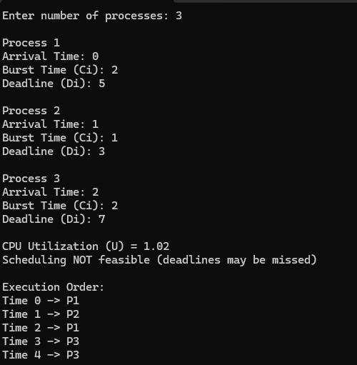

Proportional share scheduling:
#include <stdio.h>
#define MAX 10
#define TIME_QUANTUM 10
typedef struct {
int id;
int arrival;
int burst;
int remaining;
int weight;
int completed;
} Process;
int main() {
Process p[MAX];
int n, i, t = 0, total_weight = 0, completed = 0;
int total_burst = 0, idle_time = 0;

printf("Enter number of processes: ");
scanf("%d", &n);

for (i = 0; i < n; i++) {
printf("\nProcess %d\n", i + 1);
p[i].id = i + 1;

printf("Arrival Time: ");
scanf("%d", &p[i].arrival);

printf("Burst Time: ");
scanf("%d", &p[i].burst);

printf("Weight: ");
scanf("%d", &p[i].weight);
p[i].remaining = p[i].burst;
p[i].completed = 0;

total_weight += p[i].weight;
total_burst += p[i].burst;
}

printf("\nExecution Order:\n");

while (completed < n) {
int executed = 0;

for (i = 0; i < n; i++) {
if (p[i].arrival <= t && p[i].completed == 0) {

int time_slice = (p[i].weight * TIME_QUANTUM) / total_weight;
if (time_slice <= 0)
time_slice = 1;

if (time_slice > p[i].remaining)
time_slice = p[i].remaining;

printf("Time %d -> P%d (runs %d units)\n", t, p[i].id, time_slice);

p[i].remaining -= time_slice;
t += time_slice;
executed = 1;

if (p[i].remaining == 0) {
p[i].completed = 1;
completed++;
total_weight -= p[i].weight;
}
}
}

if (!executed) {
printf("Time %d -> Idle\n", t);
t++;
idle_time++;
}
}

float cpu_util = ((float)total_burst / t) * 100;

printf("\nTotal Time = %d\n", t);
printf("Idle Time = %d\n", idle_time);
printf("CPU Utilization = %.2f%%\n", cpu_util);

return 0;
}

OUTPUT:
